
SHREE CHANAKYA EDUCATION SOCIETY’S
INDIRA COLLEGE OF COMMERCE & SCIENCE
T.Y.B.Sc (COMPUTER SCIENCE) 2025-26
A
Report On
Study Room Management System

Under the Guidance of
PROF. Shweta Amol Bhoyate.

By

- Sudarshan Dhore(B-15)
- Akshay Bile(B-08)
- Aditya Dhabhade(B-85)

ACKNOWLEDGEMENT:

we sincerely wish to express deep sense of gratitude to my project guide Sharon Sir & Head of Department Mr. Janardhan Pawar For supporting and guiding us in the project.

we would also like to extend my sincere thanks to all our teachers of department for their excellent guidance & helpful suggestions. we would also like to thank them for their valuable inspiration & for their co-operation during the project work & also thank them for providing us all required facilities.

And finally we thank our college for immense encouragement for the success completion of my project.

With Thanks From,
ADTIYA DABHADE
SUDARSHAN DHORE
AKSHAY BILE

INDEX
1.Introduction of the System
- Introduction
- Problem Statement
- Motivation
- Project Scope & Limitation
- Implementation Details
2.System Analysis
- Software & Hardware Specification
- Project Implementation with Specified Technology
- Module Discussed
- Responsibilities Distribution
- ER Diagram
- Data Dictionary
3.System Design
- Use Case Diagram
- Class Diagram
- Activity Diagram
- Sequence Diagram
- Collaboration Diagram
- Deployment Diagram ➢ Component Diagram
4.User Manual
- Input Screens
- Output Screen
6.Future Enhancement
7.Conclusion
8.Bibliography

1. INTRODUCTION TO SYSTEM

Introduction
In the era of educational advancements and evolving teaching methodologies, the need for streamlined administrative tools is more critical than ever. The Study Center Management Application addresses the inherent complexities faced by study center owners managing student information, session scheduling, and payment records.
Amidst the manual handling of these tasks, inefficiencies arise, leading to potential errors, delays and a lack of synchronization in information. The motivation behind this application is revolutionize the management process, providing study center proprietors with a sophisticated, userfriendly tool to effortlessly oversee and organize their operation.

Motivation & Problem Statement
The education sector often faces challenges in managing administrative tasks efficiently, especially in study centers. Manual record-keeping of student information, session schedules, and payment tracking is prone to errors and time-consuming. This project aims to streamline these processes by developing a comprehensive desktop application for study center owners.

Project Scope and Limitations
- Scope: The project involves creating an intuitive, user-friendly application allowing study center owners to manage student data, session schedules, and payments seamlessly. Additionally, it includes automated notifications to remind students about upcoming payment dues.
- Limitations: The initial version may have limited integration with specific email providers or may be compatible only with certain operating systems due to technology constraints.

Implementation Details
- Study Center Owners/Administrators: The primary users of this application are study center proprietors, administrators, or managerial staff responsible for overseeing day-to-day operations. They will utilize the application to manage student information, session schedules, and payments efficiently.
- Educational Institutions and Study Centers: Educational institutions such as coaching centers, tutorial academies, or learning centers will benefit from utilizing this application to streamline administrative tasks, enhance organizational efficiency, and improve student engagement.
- End Users - Students: Though not direct users of the application, students attending the study centers will indirectly benefit from the system's functionality, especially through automated notifications about pending payment dues, ensuring timely reminders for financial obligations.

2. SYSTEM ANALYSIS
Software/Hardware Specifications:
- Software: Java programming language will be used as the primary development language. JDBC will facilitate database connectivity, while the GUI will be developed using Swing/JavaFX. JavaMail API will handle email notifications.
- Hardware: The application will be designed to run on standard desktop/laptop configurations without requiring high-end hardware.
- Hardware Requirements:
- Processor: Multi-core processor (intel i5) o RAM: 8GB or Higher
- Storage: SSD recommended for better work

Project Implementation with Specified Technology:
- Database Structure: The application will interact with relational database containing tables such as Customer details, model details, etc. Each table will store relevant information related to customers, their details with inquired model.
- Backend Development: Java will be used as the primary programming language for backend development. The user interface (Frontend) will feature an intuitive design using Swing /javaFX. It will allows the users to manipulate with system and perform desired work.
- Database Connectivity: JDBC will establish connection between the application and database. It will be execute SQL queries for various operations like storing customer records fetching customer information, updating customer information.
- Email Notifications: The JavaMail API will automate the process of sending email a greeting message with a brochure of inquired EV vehicle.

Modules Name
- Login form.
- Main Window.
- Add record.
- Update Record
- Search Record.
- Delete Record

Responsibility
- C56: Designing frontend using Swing/JavaFx. Designing multiple windows for Adding new student information, updating, deleting, displaying Information. Making sure it looks minimalistic and sophisticated.
- B16: Connecting frontend to the database using JDBC and implementing CRUD stack on application and make sure all functionalities work as expected and efficiently.
- B03: work on Mailing system using JavaMail and creating pdf out of all student information or particular student information. Integrating all windows together and database code together and create Documentation of project.

ER Diagram: 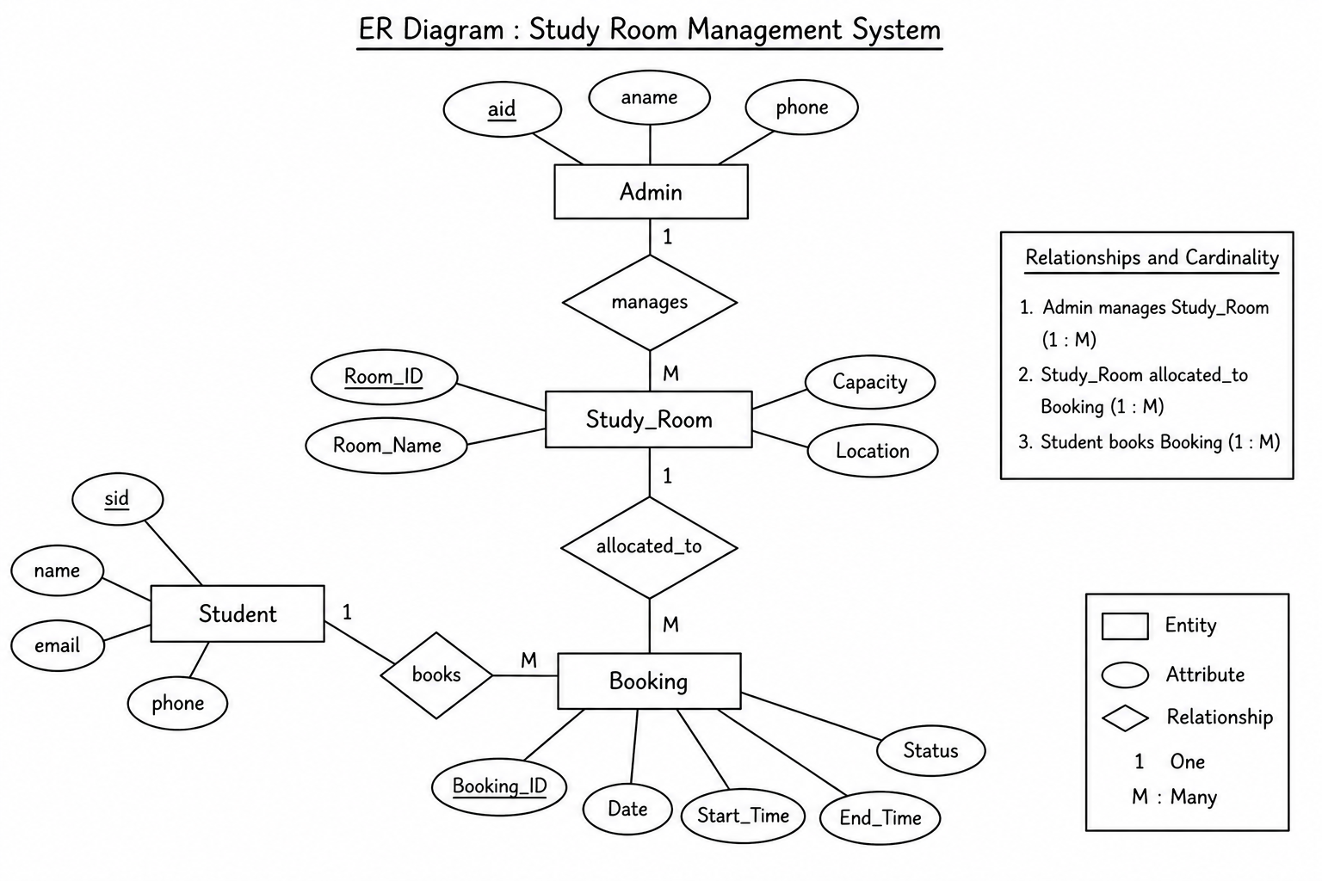

Data Dictionary: USER TABLE:

Field | Type | Description
UserID | INT | Unique identifier for each user.
Name | VARCHAR (60) | Full name of the user.
EMAIL | VARCHAR (150) | Email address of the user.
PHONE | BIGINT (25) | CONTACT NO
PARENT CONTACT | BIGINT (25) | PARENT CONTACT NO
COLLEGE | VARCHAR (300) | College Name
COURSE | VARCHAR (150) | Course enrolled
SLOT | VARCHAR (20) | Morning or Evening

Desk Table:

Field | TYPE | DESCRIPTION
DeskId | INT | UNIQUE IDENTIFIER FOR EACH RESERVATION
UserID | INT | FOREIGN KEY FROM USER TABLE
Date | DATETIME | LAST DATE AND TIME OF SUBSCRIPTION
status | VARCHAR (20) | DESK OCCUPIED OR NOT
PaymentID | INT | FOREIGN KEY FROM PAYMENT  TABLE

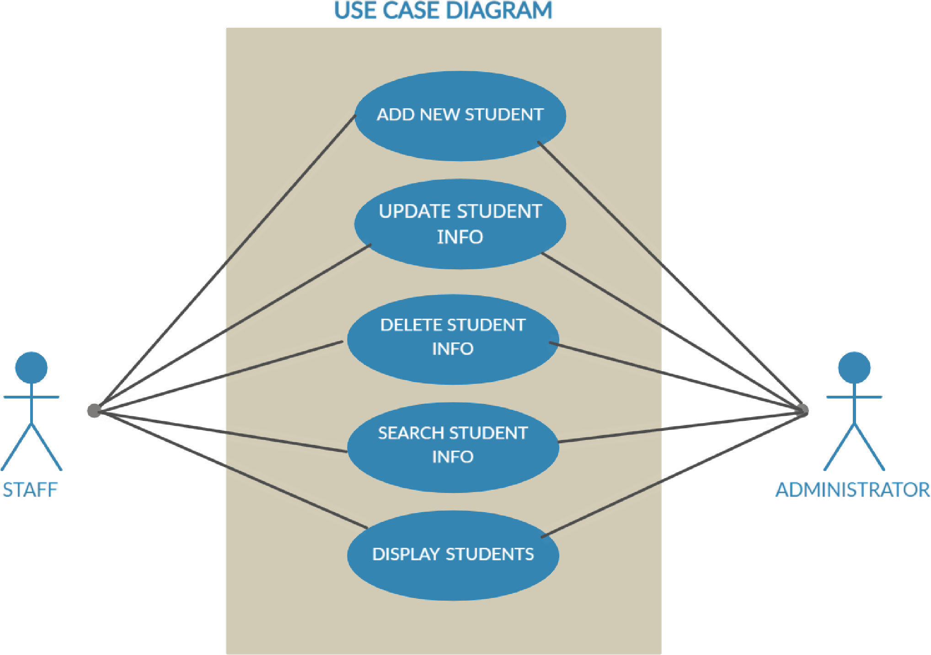
Use Case Diagram:

Class Diagram:
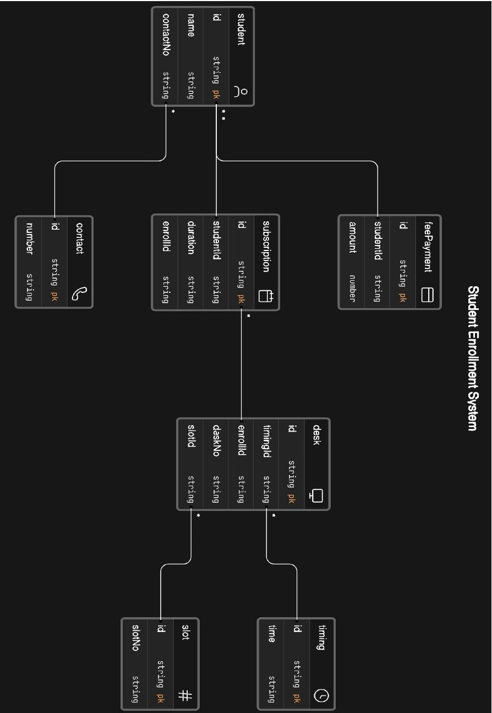

Activity Diagram:
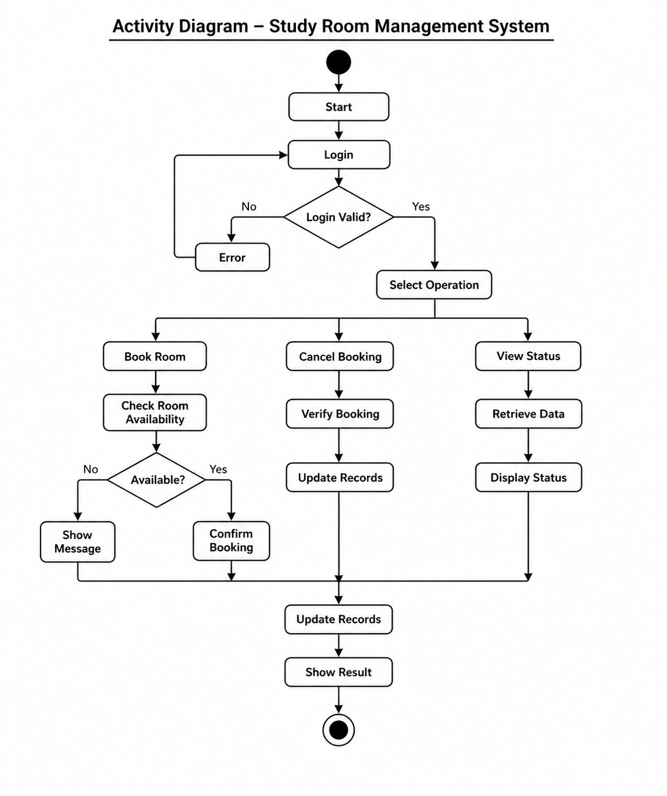

Sequence Diagram:
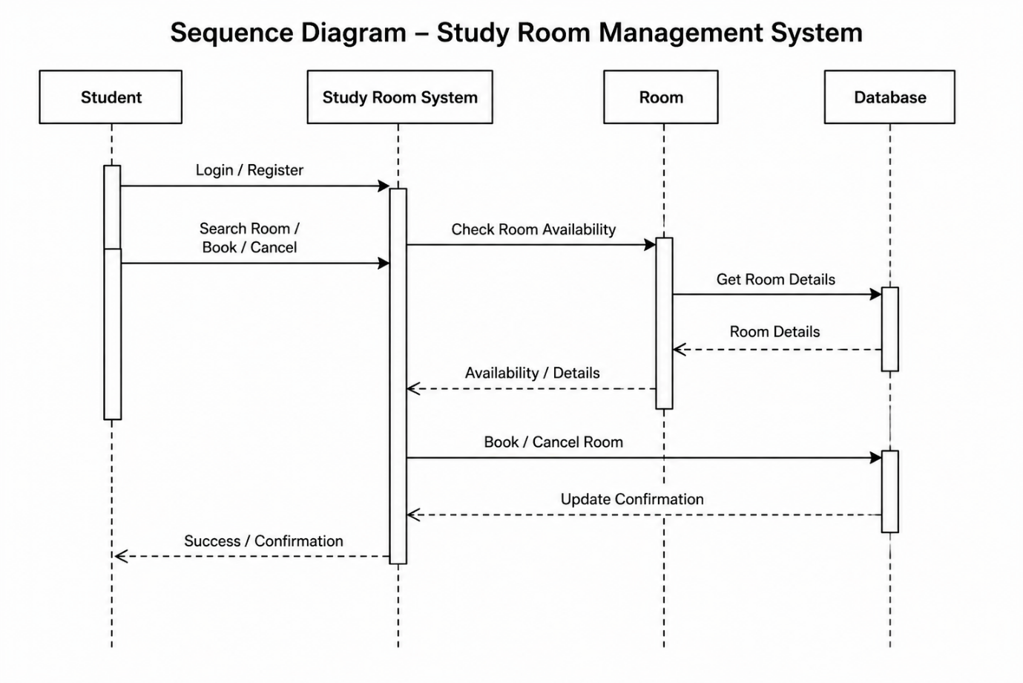

Collaboration Diagram:

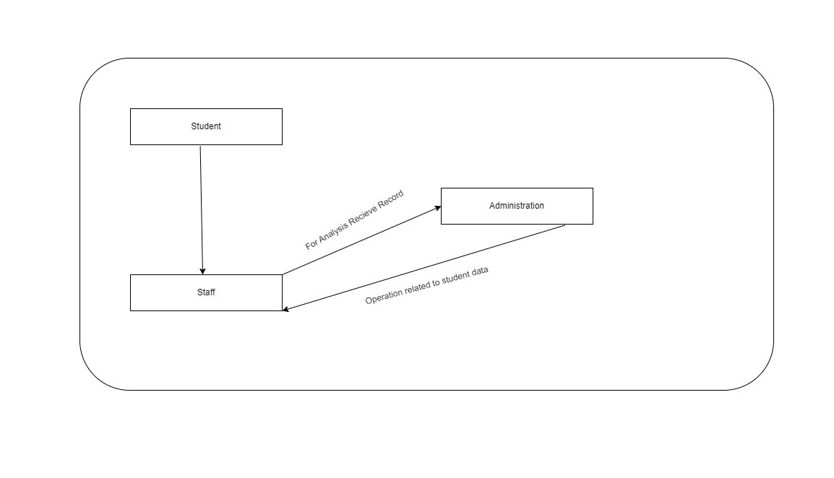

Deployment Diagram:

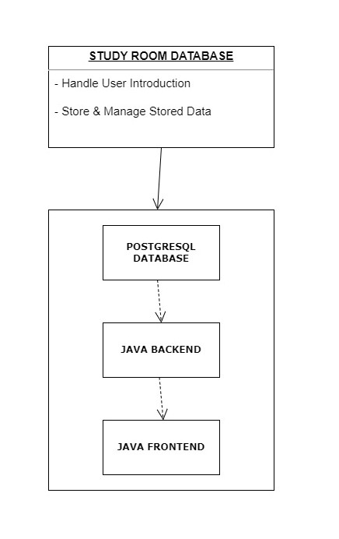

Component Diagram:

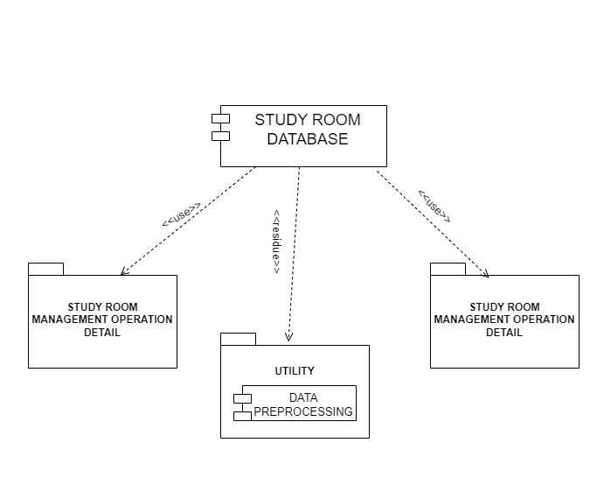

4. User Interface (Input & Output Screen):

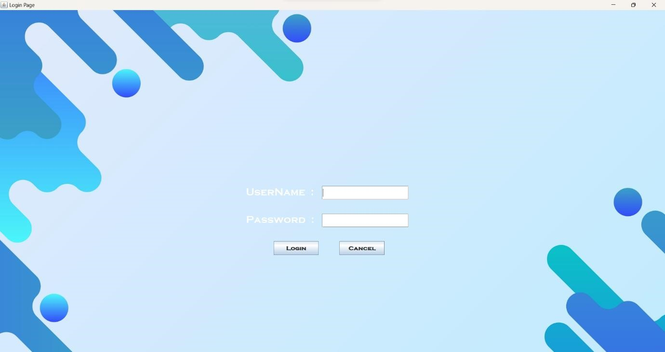
2.ADD INFORAMATION

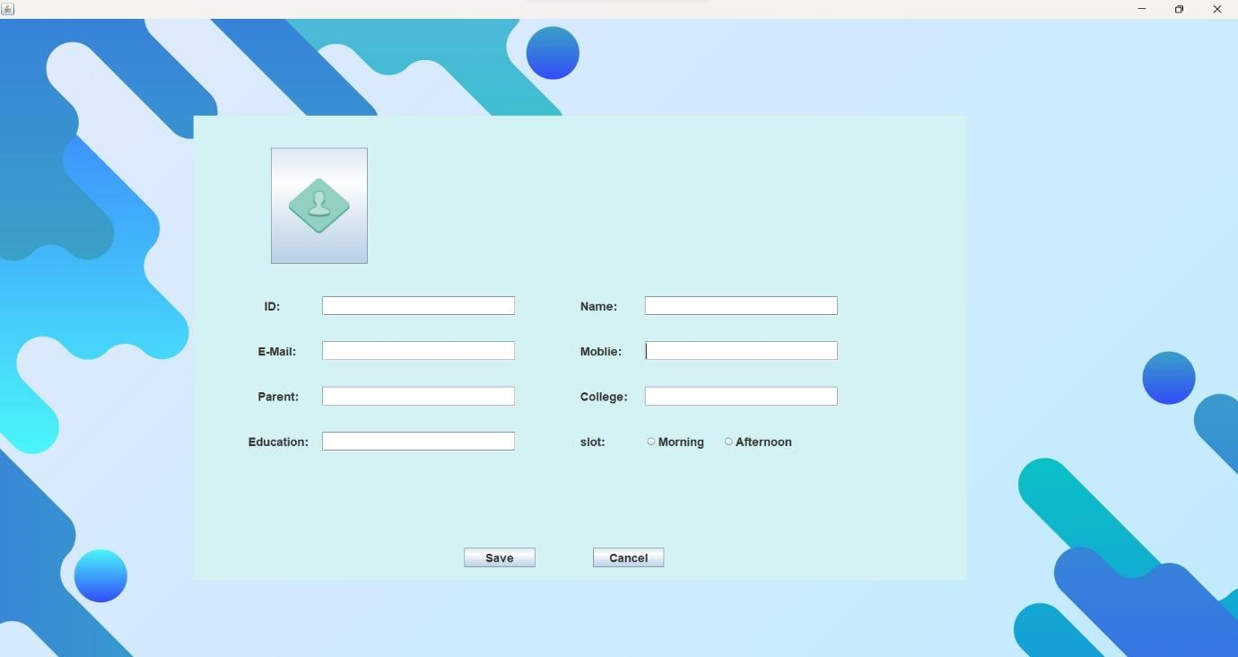

3.DELETE 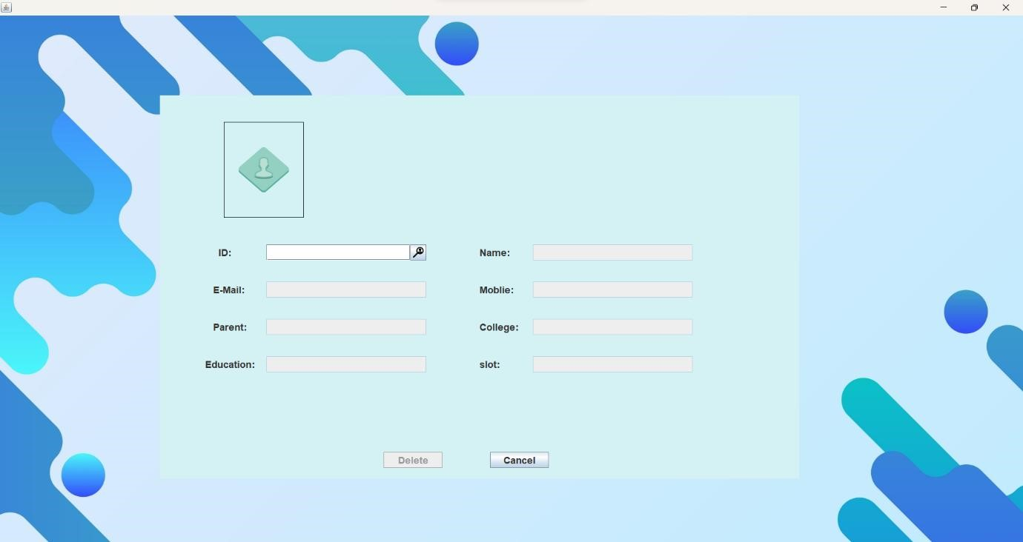

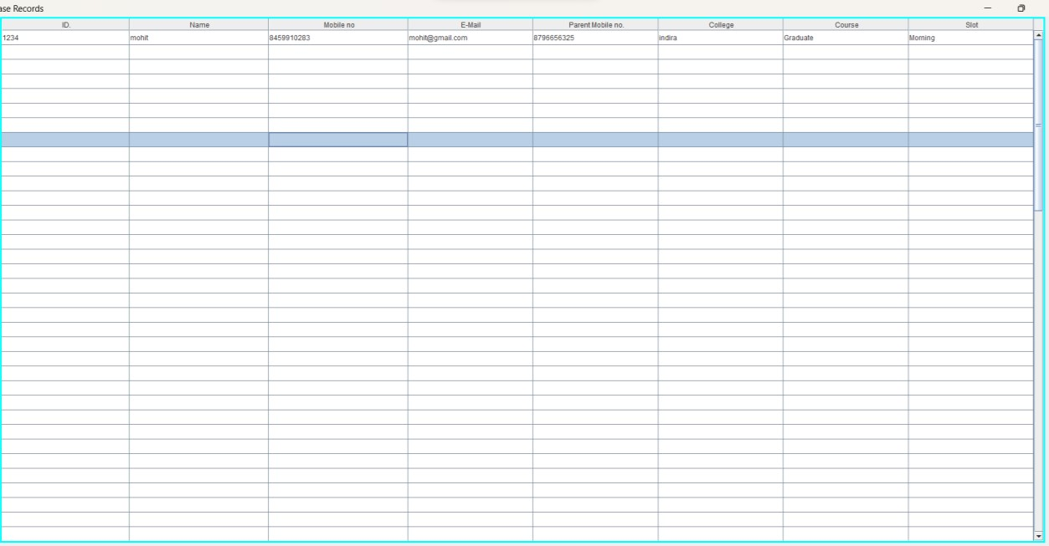

5.TESTING:
Test Case Design & Testing:

Test  scenario ID | Test  Scenario  Description | Test case ID | Test Case Description | Test Step | Expected Result | Status
TS_A_001 | Verify the login functionality of admin login page | TC_A_001 | Enter a valid username and password | - Enter Invalid username  - Enter a valid password  - Click on login button | Successful login | Pass
TS_A_001 | Verify the login functionality of admin login page | TC_A_002 | Enter a valid  username and  invalid  password | - Enter Invalid username  - Enter a valid password  - Click on login button | A popup message box to show an error  "Invalid  username” | Pass
TS_A_001 | Verify the login functionality of admin login page | TC_A_003 | Enter invalid username and valid password | - Enter Invalid username  - Enter a valid password  - Click on login button | A popup message box to show an error  "Invalid  username” | Pass
TS_A_001 | Verify the login functionality of admin login page | TC_A_004 | Enter invalid  username and  invalid  password | - Enter invalid username  - Enter invalid password  - Click on login button | A popup message box to show an error  "Invalid  username Password” | Pass
TS_A_002 | To verify main frame | TC_A_01 | All modules  are clickable to  open | 1.login  2.click all  module one by one  3.verify is  corresponding module is opening/not | All modules are functioning well as opening with corresponding button | Pass
TS_A_003 | To verify add module | TC_A_01 | Generating new entry as per form and store into database. | 1.login and open enquiry form note id 2.again enquiry form open and  verify id is  Random/Not | All data gets accepted successfully and stored in database. | Pass
TS_A_003 | To verify add module | TC_A_02 | Submission of enquiry form | 1.login and open enquiry form  2.Fill and submit form | Form submitted successfully | Pass
TS_A_003 | To verify add module | TC_A_03 | Close enquiry form | 1.login and open enquiry form | Enquiry form closed and returned to mainframe | Pass

 |  |  |  | 2.Close enquiry form
TS_A_004 | To verify the update form | TC_A_01 | Search id and update the form | 1.Login and open update form  2.click search button  3.update and getting data 4.And update data | ID data updated successfully | Pass
TS_A_004 | To verify the update form | TC_A_02 | Submission of update form | 1.login and open update form  2.Fill and submit form | Form submitted successfully | Pass
TS_A_004 | To verify the update form | TC_A_03 | Close update form | 1.login and open update form  2.Close update form | Update form closed and returned to mainframe | Pass
TS_A_005 | To verify delete form | TC_A_01 | Search id and delete the form | 1.Login and open delete form  2.click search botton  3.delete and getting data 4.And delete data | ID data updated successfully | Pass
TS_A_005 | To verify delete form | TC_A_02 | Submission of delete form | 1.login and open delete form  2.Fill and submit form | Form deleted successfully | Pass
TS_A_005 | To verify delete form | TC_A_03 | Close delete form | 1.login and open delete form  2.Close delete form | Delete form closed and returned to mainframe | Pass
TS_A_006 | To verify students tab | TC_A_01 | Display all records in one frame | 1.Login and click display all module  2.select students 3.click ok | All records are displayed in table format | Pass
TS_A_007 | To verify Search | TC_A_02 | Display all records one by  one | 1.Login and click display all  module  2.Select Search | Record displayed for given ID | Pass
 |  |  |  | 3.Enter ID to be search.

6.FUTURE ENHANCEMENT:

For future enhancements to the EV Bike Showroom reception handling project, consider implementing the following improvements to elevate customer experience and operational efficiency:
- Interactive Display Screens: Install interactive display screens in the showroom lobby to showcase product features, specifications, and customer testimonials. These screens can also provide information about current promotions, financing options, and upcoming events, enriching the showroom experience for visitors.
- Virtual Reality (VR) Test Rides: Offer virtual reality test rides for customers to experience the thrill of riding electric bikes in different environments. VR technology can simulate realistic riding scenarios, allowing customers to explore various models and configurations before making a purchase decision.
- Customer Feedback System: Implement a feedback system to gather input from customers about their showroom experience. This can be done through inperson surveys, online forms, or follow-up emails. Use this feedback to identify areas for improvement and make data-driven decisions to enhance customer satisfaction.
By implementing these future enhancements, the EV Bike Showroom reception handling project can create a more immersive and engaging experience for customers, strengthen relationships with the community, and drive business growth in the electric vehicle market.

7.CONCLUSION:

In conclusion, our EV Bike Showroom Reception Handling Project embodies the essence of seamless customer experience and efficient operations. By prioritizing professionalism, responsiveness, and attention to detail, we're not just managing inquiries and appointments; we're curating memorable experiences for every visitor who walks through our doors.
As we move forward, let's continue to uphold our commitment to excellence, ensuring that every interaction reflects our dedication to customer satisfaction and brand integrity. Together, we're not just shaping the perception of our showroom; we're setting a new standard for customer service in the electric vehicle industry.
With passion in our hearts and efficiency in our actions, let's welcome each visitor with warmth, knowledge, and enthusiasm, leaving them not just impressed, but excited to embark on their electric journey with us. This showroom isn't just a destination; it's a gateway to a sustainable future—one where every interaction leaves a lasting impression. Welcome to our EV Bike Showroom, where excellence meets excitement, and where every visitor feels valued and inspired.

8. BIBLIOGRAPHY

- www.w3school.com
- www.scribd.com
- www.greeksforgreeks.org

- Reference Books:
  - Software Engineering: A PR actioner’s Approach
Book by Bruce Maxim & Rogers S. Pressman
  - Effective Methods for Software Testing, Third Edition By William E. Perry, William E. Perry Enterprises, Inc.
Released May 2006
Publisher(s): willey

- AI Tools:
ChatGPT
BlackBox.io
Draw.io

